Education Resources Allocation and Distribution System
May Thu Zin, Nyein Hsu Lwin
Student, 5th Year, B.C.Sc.
University of Computer Studies, Hinthada
Supervised By
Khin San Wai
Department of Information Technology Supporting and Maintenance
University of Computer Studies, Hinthada
Abstract: Educational resource management is essential for ensuring that textbooks, teacher manuals, teacher guides, and school supplies are available in the required quantities. A computerized system can help reduce manual work, improve calculation accuracy, and organize resource allocation and distribution. In this project, the Education Resources Allocation and Distribution System was developed for the District Education Office to manage educational resources systematically. The system supports master data management, student count and quota preparation, textbook and school supply allocation, and teacher manual and teacher guide receipt and distribution. It also provides a dashboard for viewing allocations, distributions, remaining quantities, and student count information. The system helps make educational resource management more systematic and efficient.
Keywords: educational resources, resources allocation, quota calculation, resources distribution, inventory management
INTRODUCTION
Educational resource management is essential for ensuring that schools receive the necessary materials in the required quantities. At the District Education Office, resources such as textbooks, teacher manuals, teacher guides, and school supplies need to be managed through student counts, quota preparation, allocation, and distribution. These activities require accurate information because resource quantities are often determined based on student numbers and available stock. When these activities are handled manually, calculations and record-keeping take more time and are difficult to maintain consistently. The Education Resources Allocation and Distribution System provides a more organized way to manage educational resources, reduce repeated manual work, and support accurate allocation and distribution based on student counts and other required information.
PROBLEM
Managing educational resource allocation and distribution manually can be time-consuming and may result in repeated data entry and calculation errors. It is also difficult to track allocation, distribution, remaining quantities, and student counts when records are kept separately. In addition, checking previous records and preparing accurate resource quantities requires extra time and effort. These problems delay resource distribution and make it harder for administrators to monitor overall resource availability. Therefore, a web-based system is needed to organize resource information, support accurate calculations, and maintain allocation and distribution records efficiently.

APPROACH
The system has two main roles: Super Admin and Admin. Both users must log in to access the system and can view the dashboard, which provides summary information about allocations, distributions, remaining quantities, and student counts. As show in figure.1 (a) the Super Admin can perform all functions available to the Admin and has additional privileges, including managing administrator accounts and deleting records. These role-based permissions help maintain system security and data accuracy. The system also supports Excel and PDF export for reporting and record-keeping. After completing their tasks, both users can log out to terminate their sessions and prevent unauthorized access.
As show in figure.1 (b) the Admin can manage master data, student counts, quotas, textbook allocations, school supply records, and teacher manuals and guides. However, the Admin cannot manage administrator accounts or delete records.

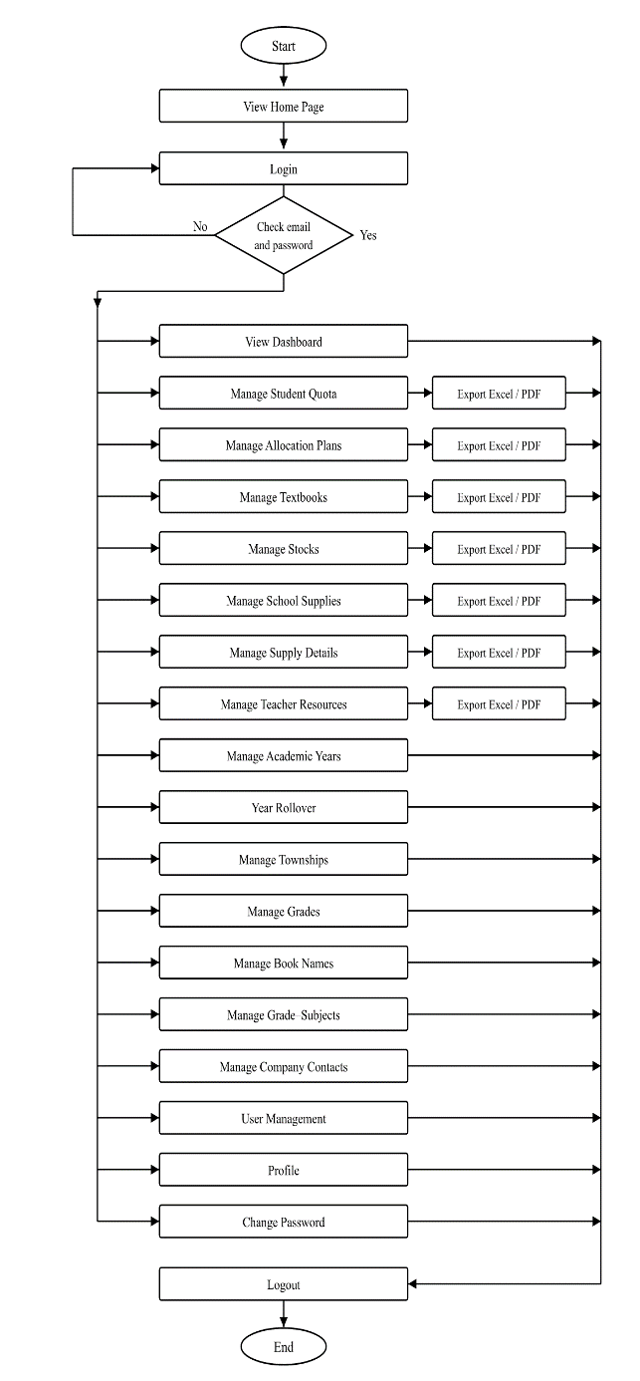  Super Admin | 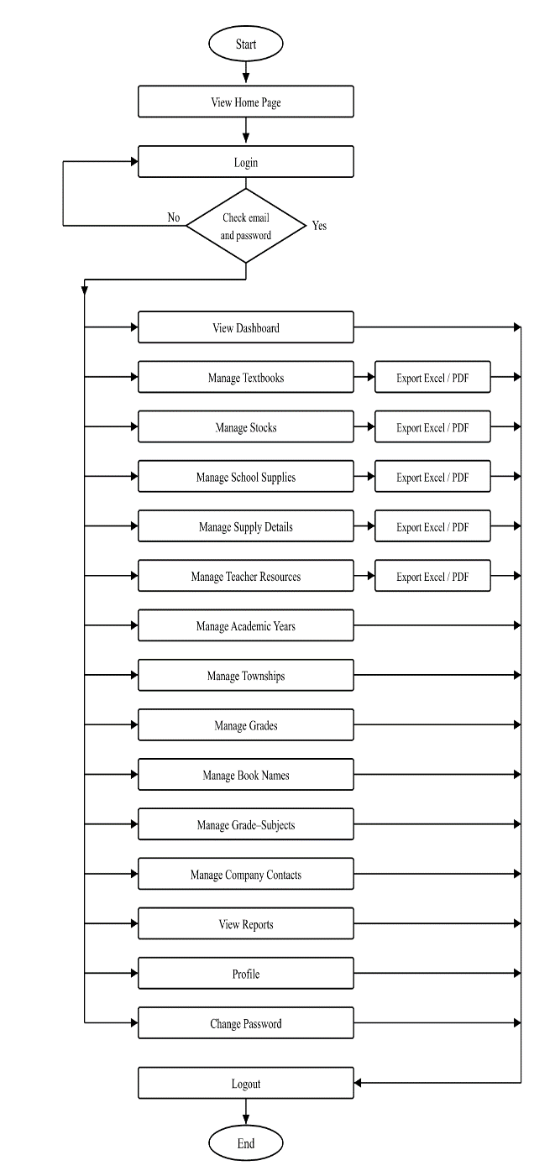  Admin
Figure 1(b). System Flow Diagram for Admin

Figure 1(a). System Flow Diagram for Super Admin

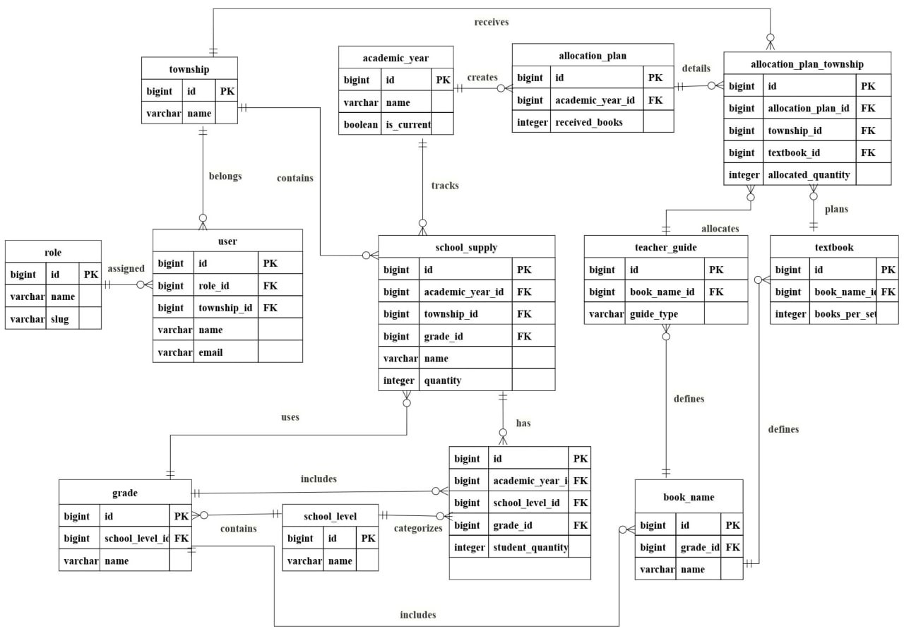
Figure 2. Database Architecture
Figure 2 presents the Entity Relationship Diagram (ERD) for the Education Resources Allocation System (DERAS). The diagram shows how the main database tables are organized and how they connect to one another. It supports clear data modeling by defining primary keys, foreign keys, and table relationships so related records stay consistent and can be queried efficiently. In DERAS, the ER diagram includes the core tables used for basic data, allocation, distribution, and user access. These tables are managed by Admin and Super Admin users. The main tables include:
- academic_years stores academic year information and the current-year flag
- townships stores township information
- grades stores grade / class-level information
- book_names stores subject or book titles
- categories stores book-type categories used with grade–book mapping
- grade_book_names links grades, book names, and categories
- quotas / quota_lines stores student quota totals and line details by school level
- school_counts stores school-count values used in supply calculations
- allocation_plans / allocation_plan_townships stores textbook allocation plans and township-level allocation details
- textbooks stores regular textbook distribution records
- stocks stores extra / stock distribution records
- previous_year_balances stores carry-forward balances from previous years
- supply_items / supply_details stores supply issue items and issue details
- school_supply_items / school_supply_allocations stores supply items and township allocation quantities
- teacher_guides stores teacher-guide receipt quotas
- teacher_guide_township_allocations stores township distribution quantities for teacher guides
- teacher_guide_issues and teacher_guide_issue_townships store issue headers and township issue quantities
- teacher_guide_summaries stores summary balances and distributed totals
- users, roles, permissions and role_permission store login accounts and role-based access control
Each operational table is linked through primary and foreign keys to maintain referential integrity. Most allocation and distribution tables connect to academic year, township, grade, and book or item references. The ERD also shows cardinality, mainly one-to-many relationships, to reflect how one academic year or township can relate to many allocation and distribution records. Overall, Figure 2 provides the database foundation for quota planning, resource allocation, distribution recording, and secure user management in DERAS.
RESULTS
The Education Resources Allocation and Distribution System provides a centralized platform for managing educational resources, including student counts, quotas, allocations, distributions, and teacher manuals and guides. It also provides Excel and PDF export functions for reporting and record-keeping. The system helps administrators manage resource information in an organized manner and reduces the need for repeated manual calculations and fragmented record-keeping.
The dashboard presents key information through summary cards, donut charts, and bar charts, allowing administrators to review and compare resource allocations, distributions, remaining quantities, and student information by township and education level. These visual summaries provide a clearer overview of the current resource situation and support administrative decision-making. Role-based access control also ensures that Super Admin and Admin users can perform functions according to their assigned permissions.
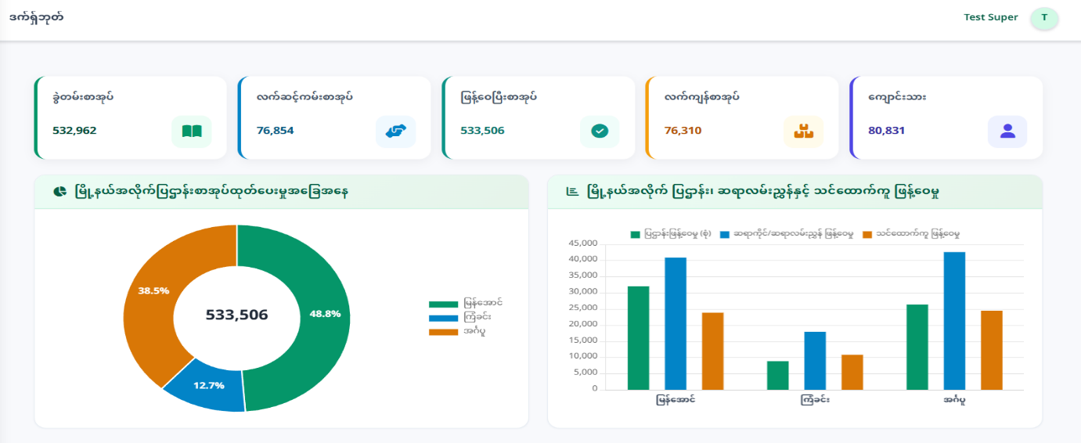

Figure 3. Dashboard of the Education Resources Allocation and Distribution System

In Figure 3, the donut chart shows textbook distribution by township, while the bar chart compares textbook, teacher guide, and teaching aid distribution across townships.
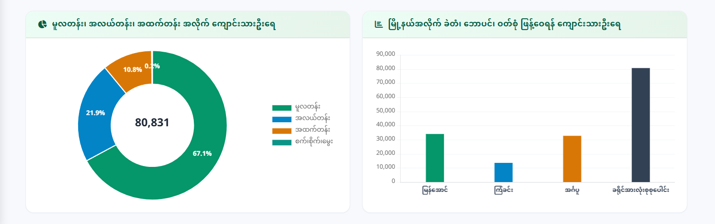

Figure 4. Dashboard of the Education Resources Allocation and Distribution System

In Figure 4, the donut chart shows student counts by education level, while the bar chart presents student counts for the distribution of pencils, pens, and uniforms by township. 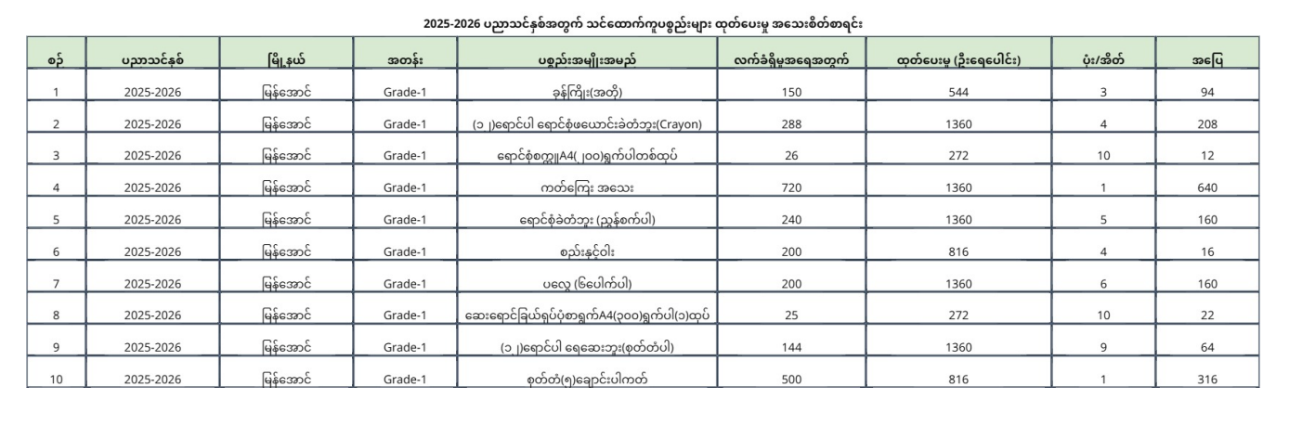
Figure 5. List of Teaching Aids Distribution for the 2025-2026 Academic Year

Figure 5 shows an example report generated by the system for teaching aid records. The table lists the academic year, township, grade, item name, received quantity, total distributed amount, number of boxes/bags, and remaining balance. Such reports can be exported in Excel or PDF format to support record-keeping and administrative review. Overall, the system reduces manual work, improves the accuracy of calculations and records, and provides a more organized approach to educational resource management and reporting.
CONCLUSION
The Education Resources Allocation and Distribution System was developed to improve the management of educational resources within the District Education Office. It addresses the limitations of manual resource management by providing a centralized web-based platform to manage textbooks, teacher manuals, teacher guides, and school supplies. The system supports quota preparation, allocation calculations, stock management, and distribution record management, thereby reducing manual work, minimizing errors, and improving the accuracy and accessibility of resource records. By providing a systematic and efficient approach to educational resource management, the system contributes to more organized resource allocation and distribution and supports the effective administration of educational resources.
REFERENCES
- Matt Doyle, “Beginning PHP 5.3”, 1st Edition, Wiley Publishing, ISBN-10: ‎ 9780470413968x, 2009.
- Tom Bulter and Kevin Yank, “PHP & MySQL Novice to Ninja”, 7th Edition, Site Point Pty, Limited, Australia, 2024. http://classes.jgspectrum.com/classes/320_S24/LectureNotes/1-13_PHP_and_MySQL_Novice_to_Ninja_ed7_with_highlights.pdf.
- O’Reilly, “Head First PHP & MySQL”, 1st Edition, O'Reilly Media, Inc., 2008.
- Janet Valade, “PHP 5 For Dummies”, Hoboken, NJ: Wiley Publishing. ISBN: 0764541668, Indianapolis, Indiana, 2004.
- Paul McFedries, “HTML, CSS, & JavaScript All-in-One for Dummies”, 1st Edition, Wiley Publishing, ISBN: 978-1-394-16472-1, 2023.
- Myat Thazin Soe, “PADDY PESTS INFORMATION SYSTEM”, University Journal of Student Projects and Research, Volume 1, 2024, Hinthada, Myanmar, https://ucsh.edu.mm/wp-content/uploads/2024/10/PADDY-PESTS-INFORMATION-SYSTEM.pdf
- Nanda Kyaw, Saw Hla Nandar, “SmartGrade: Grading Certificate Information System (Client-Server)”, University Journal of Student Projects and Research, Volume 2, 2025, Hinthada, Myanmar, https://ucsh.edu.mm/wp-content/uploads/2025/10/SmartGrade-Grading-Certificate-Information-System.pdf
- Lin Lat Nay Chi, Nilar Kyaw , “Construction Materials Inventory Management System”, University Journal of Student Projects and Research, Volume 2, 2025, Hinthada, Myanmar, https://ucsh.edu.mm/wp-content/uploads/2025/10/Construction-Materials-Inventory-Management-System.pdf
- Win Lei Lei Htun, Hnin Wutt Yee Zaw, “Dhamma Online Learning Platform”, University Journal of Student Projects and Research, Volume 2, 2025, Hinthada, Myanmar, https://ucsh.edu.mm/wp-content/uploads/2025/10/Dhamma-Online-Learning-Platform.pdf
- Nan Hsu Wai, “The Fashion Shop Online Platform”, University Journal of Student Proj ects and Research, Volume 2, 2025, Hinthada, Myanmar, https://ucsh.edu.mm/wp-content/uploads/2025/10/The-Fashion-Shop-Online-Platform-1.pdf

